**Meghan Ng**

**Geog 360 AC**

**Tutorial 3**

**11 October 2016**

**Map 0. Choropleth of carbon footprints** (the narrow view)

<http://arcg.is/2e7GQ8d>

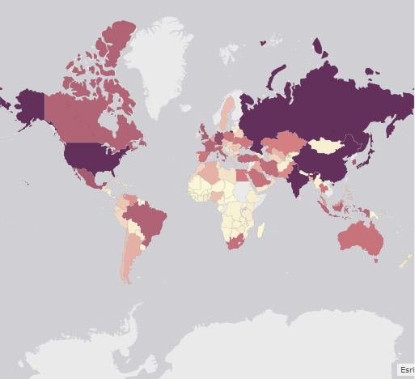

**Map 1. Proportional symbol map of carbon footprints**(the balanced picture)

<http://arcg.is/2e7HzGl>

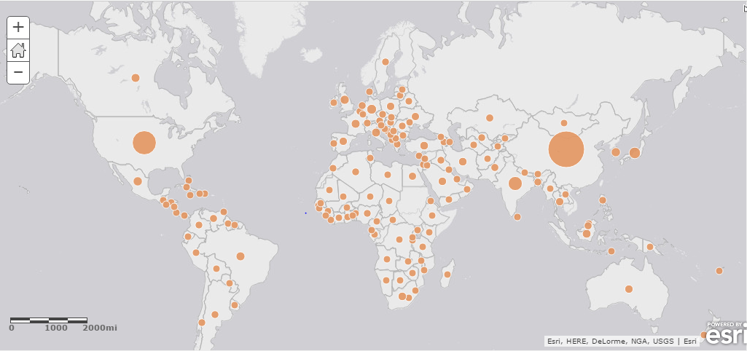

With Map 1, I can easily understand that the US and China are the biggest carbon emitters in the world, but sometimes I cannot see the circle for Russia (depending on the zoom), even though it is a big emitter. I understand that this is attributed to each country’s land size, but it is somewhat misleading if I’m looking for countries that emit the most carbon. In addition, the circles in Africa on Map 1 are about the same size, making it harder to tell which countries there emit more carbon, whereas it is easier to tell with the different colors in Map 0.

**Map 2. Choropleth of carbon footprint per unit area**(the broad view)

<http://arcg.is/2e7L53G>

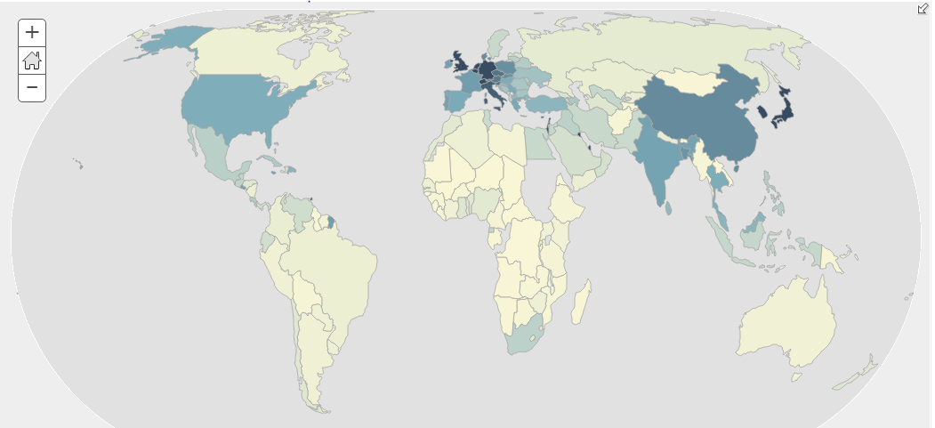

**Map 3. Choropleth of Carbon emissions per capita** (the human picture)

<http://arcg.is/2dIcSJM>

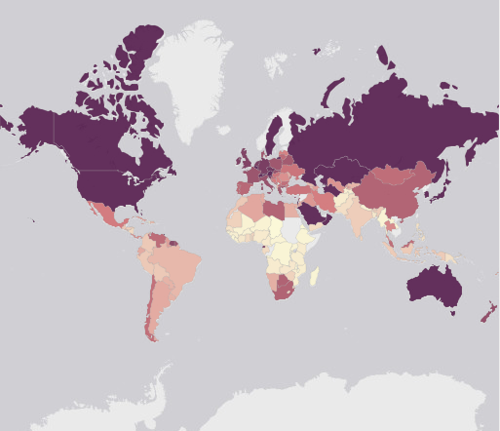

**Concluding Reflections**

I think the last map (Map 3) best allows map users to understand carbon footprints. I believe it is best to understand carbon footprints from a human perspective – knowing that we all unnaturally contribute to carbon emissions is a good wake up call to take measures to decrease our carbon output. Perhaps something I would add to Map 3 would be to additionally distort and size each country by population so this attribute becomes clearer.